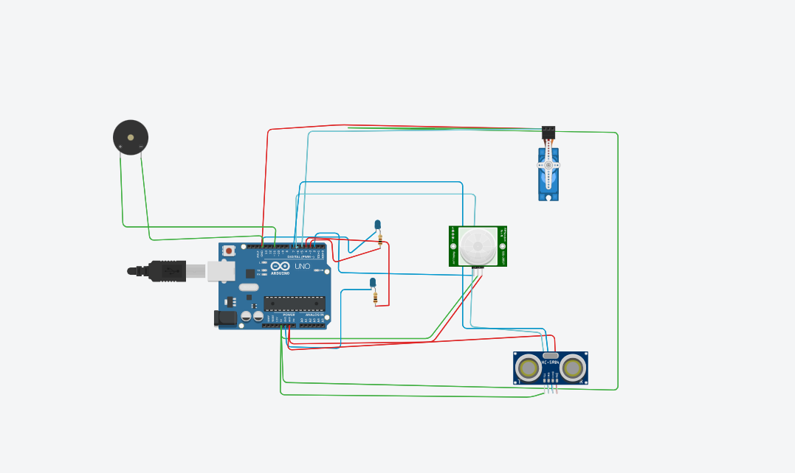

**LINK**: [*https://www.tinkercad.com/things/kRCcHdj1zyb-smart-home-automation/editel?sharecode=PnycpIxwQgcPaxXPRVY1gT-3CFnTtjckfTfJuMPSjoc*](https://www.tinkercad.com/things/kRCcHdj1zyb-smart-home-automation/editel?sharecode=PnycpIxwQgcPaxXPRVY1gT-3CFnTtjckfTfJuMPSjoc)

**CODE:**

**#include <Servo.h>**

**Servo a;**

**int trigger=6;**

**int echo=7;**

**int motion=2;**

**int led1=3;**

**int led2=4;**

**void setup()**

**{**

**Serial.begin(9600);**

**pinMode(trigger,OUTPUT);**

**pinMode(echo,INPUT);**

**pinMode(motion,INPUT);**

**pinMode(led1,OUTPUT);**

**pinMode(led2,OUTPUT);**

**a.attach(5);**

**a.write(0);**

**digitalWrite(led1,LOW);**

**digitalWrite(led2,LOW);**

**}**

**void loop()**

**{**

**int p = digitalRead(motion);**

**if(p)**

**{**

**digitalWrite(led1,HIGH);**

**digitalWrite(led2,HIGH);**

**tone(11,5000);**

**delay(5000);**

**digitalWrite(led1,LOW);**

**digitalWrite(led2,LOW);**

**noTone(11);**

**}**

**digitalWrite(trigger,LOW);**

**digitalWrite(trigger,HIGH);**

**delayMicroseconds(10);**

**digitalWrite(trigger,LOW);**

**float duration = pulseIn(echo,HIGH);**

**float dist = (duration*0.0343)/2;**

**if(dist<50)**

**{**

**a.write(90);**

**delay(5000);**

**a.write(0);**

**}**

**}**